Wassenaar Arrangement

on

Export Controls for Conventional Arms and

Dual-Use Goods and Technologies

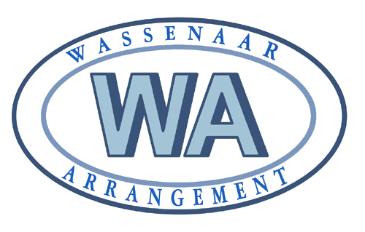

**PUBLIC DOCUMENTS**

**Volume II**

**List of Dual-Use Goods and Technologies**

**and**

**Munitions List**

Compiled by the Wassenaar Arrangement Secretariat

December 2017